**MRU Curriculum (Version 2.0)**

This proof-of-concept web application was created Tyler Rop, Bachelor of Computer Information Systems Student at Mount Royal University (MRU).

**Enhancements and Changes**

* The search results page (searchResults.php) has been developed to provide search results for the user.
* Search results are displayed by default in descending order by Request ID.
* Users are able to search by Request ID, Title, Submitter Name, Email, Creation Date, or State through the search box.
* Sorting is possible for search results based on any of the searchable criteria.
* If a user clicks on one of the buttons in the table header, then the table will be sorted by the selected category in descending order and reveal an arrow in the selected column. If the user then the same header again then the table will be sorted via the same category in an ascending manor.
* Credit for the free to use sorting jQuery Animated Table Sorter 0.2.2 plug in goes to Matan Hershberg Web Development (<http://www.matanhershberg.com/plugins/jquery-animated-table-sorter/>).

**Search Results**

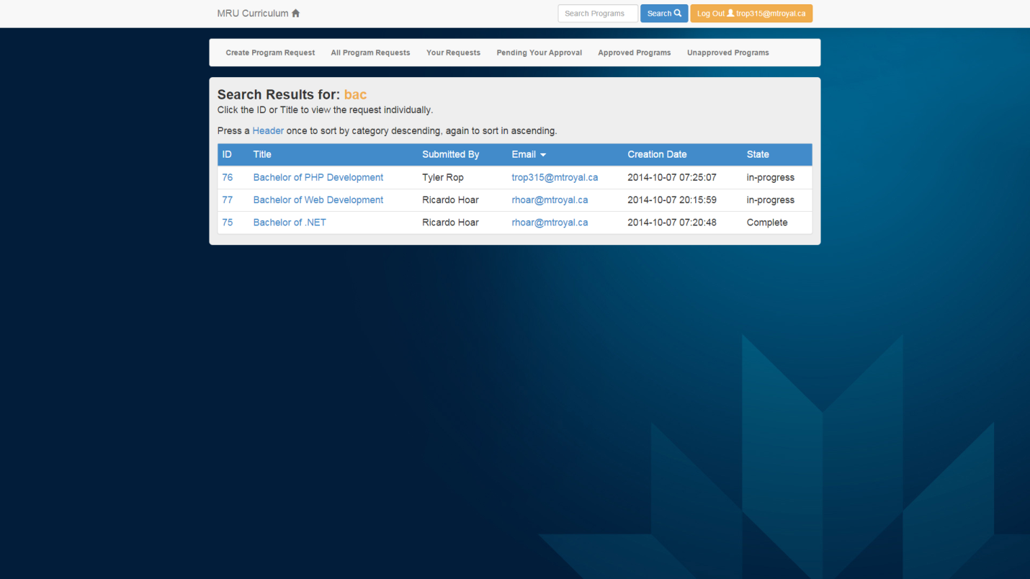

* The Create Program form now had server side processing that informs a user of necessary changes for the Program Name field.
* A wrapper div element and article elements have also been added to the Create Program form to utilize the jQuery Slippry slider (<http://slippry.com/>) for making the form become horizontally shifting/‘multi-paginated’ with when the user has JavaScript enabled. This is navigated with the fading arrows and page numbers.
* Some contextual information is given to the user once the fill out the Program Name and First Course Term Fields.
* The form HTML code itself did not require any changes besides some semantic sectioning with div and article elements and a class for required input elements.
* The form gracefully degrades to a single large form when the user does not have JavaScript enabled.
* Additional CSS, JavaScript, and jQuery files have been linked through the website’s header and footer for updated visual styling in various areas of the web app.

**‘Multi-paginated’ Create a Program Form – Part 1**

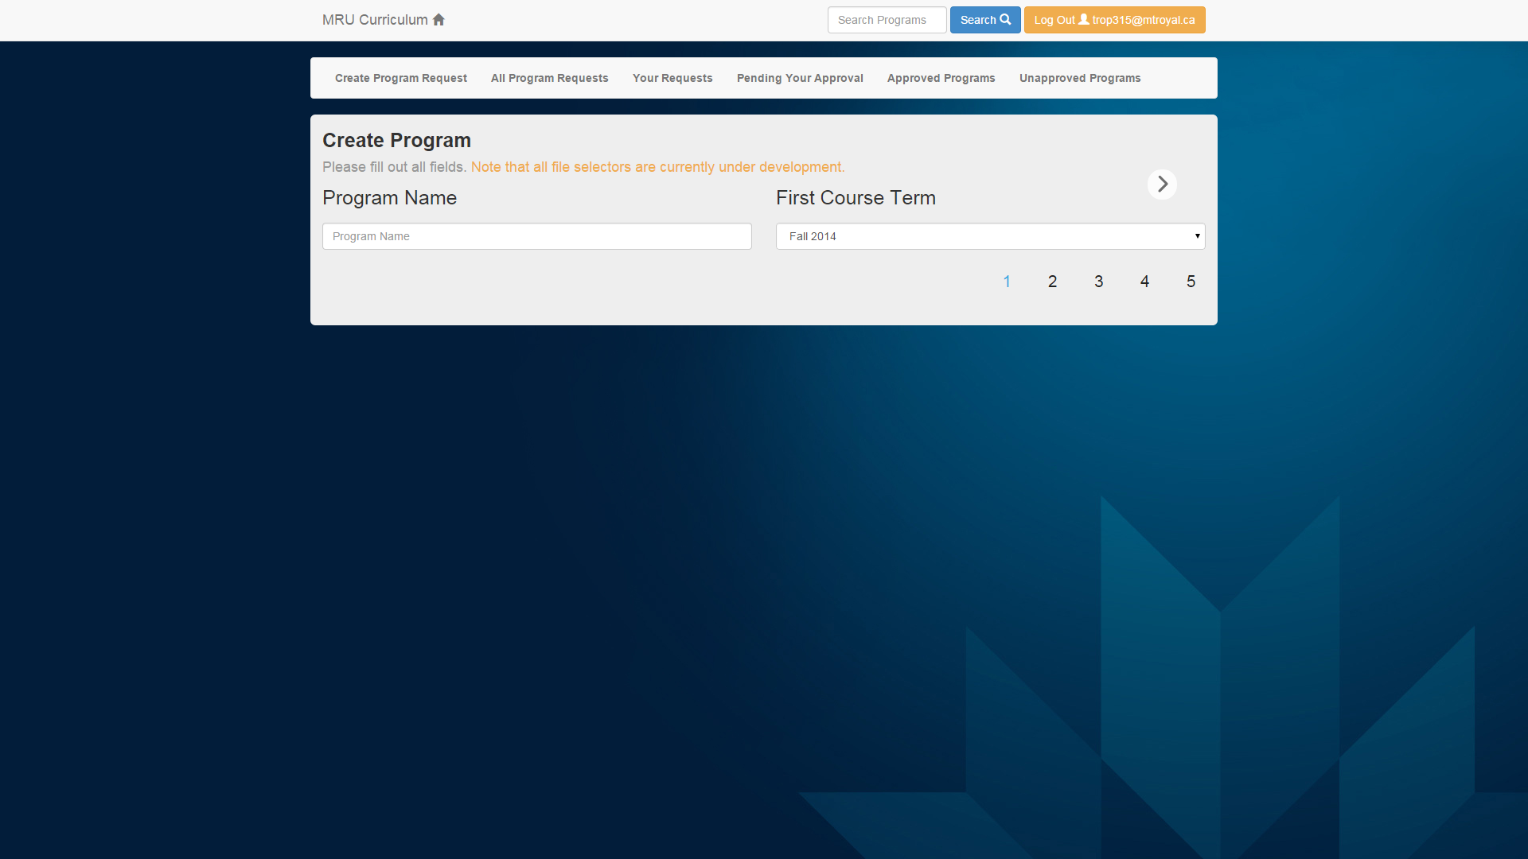

**– Part 2**

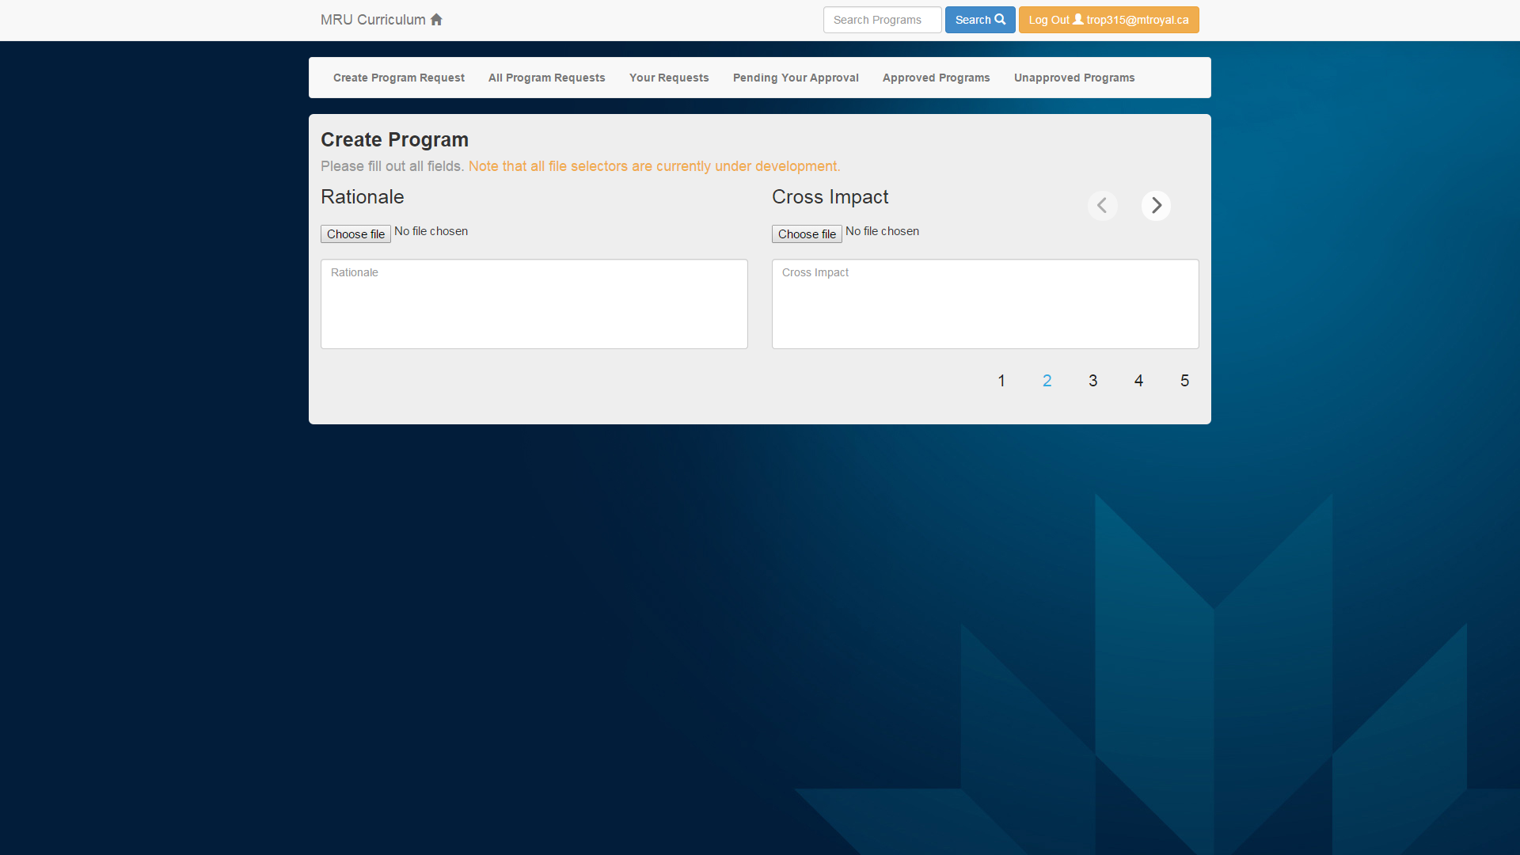

**– Part 3**

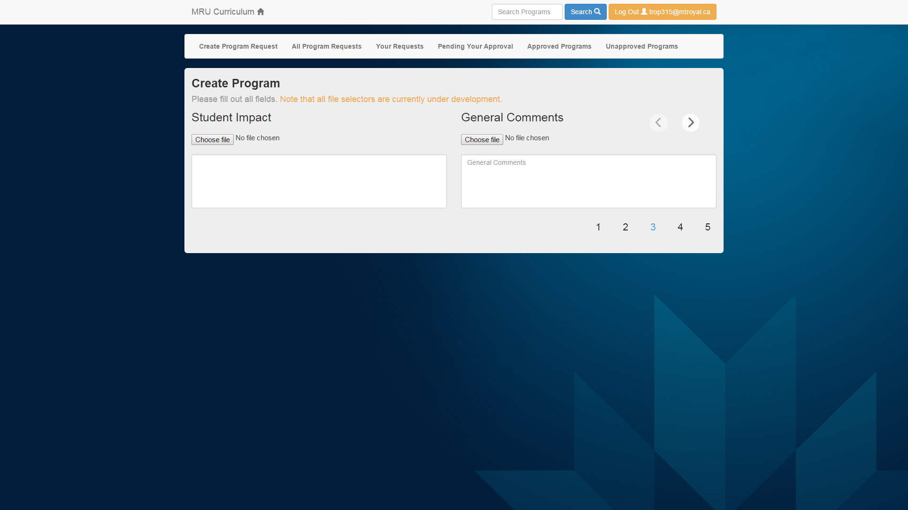

**– Part 4**

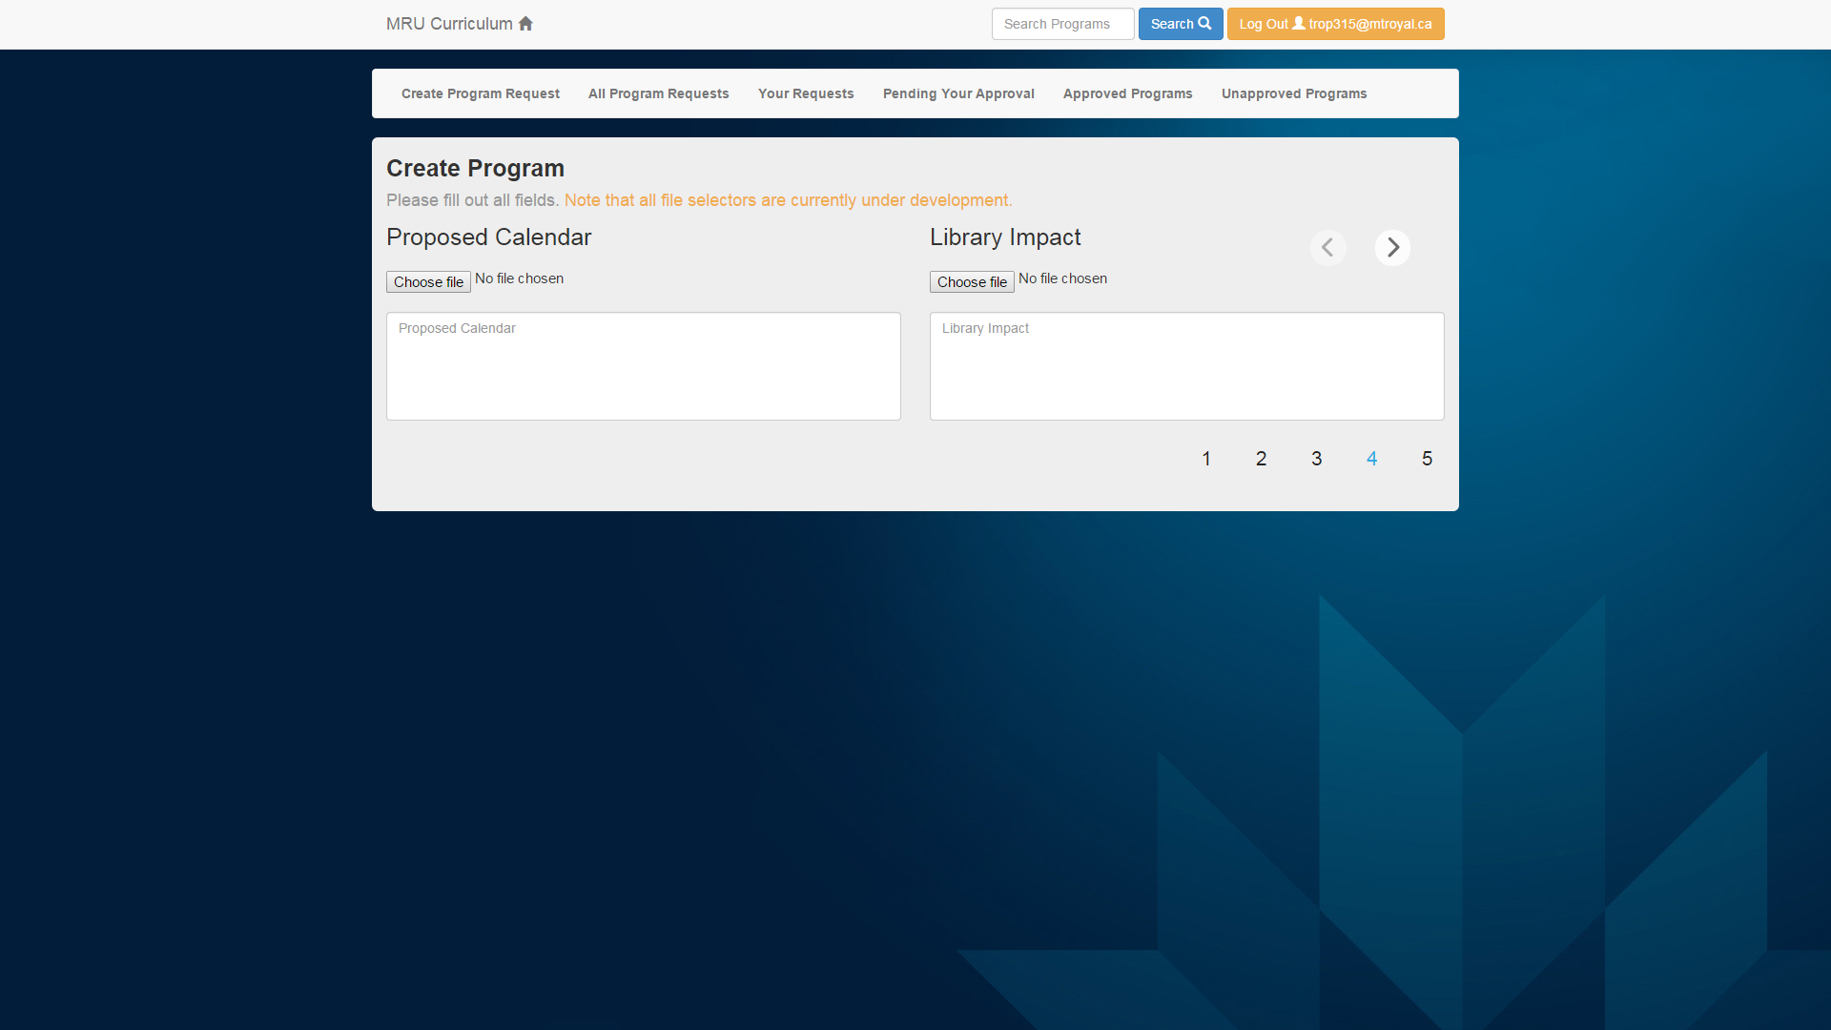

**– Part 5**

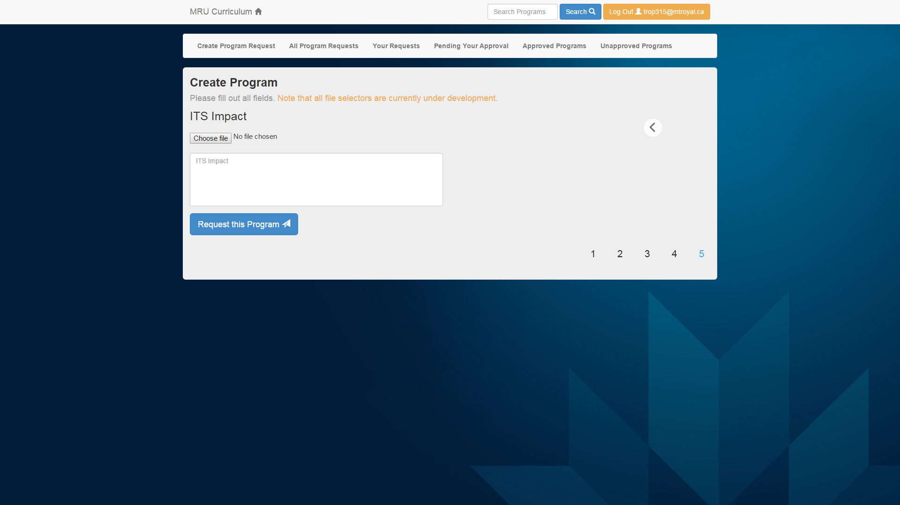

**Contextual Information (shown here in Part 2 due to the Program Name and First Course Term being filled out as “Bachelor of Web Development” and “Spring 2015” respectively)**

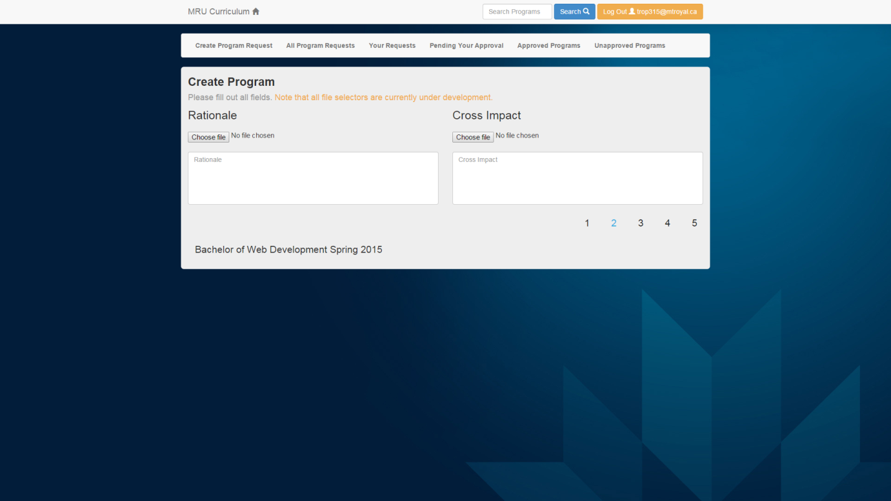

**Create Program form with JavaScript disabled**

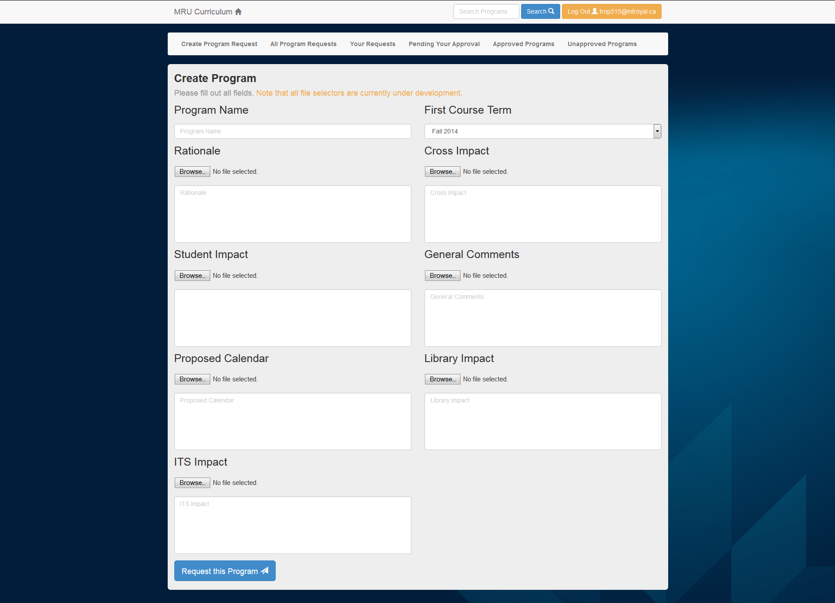

**User Log-In Information**

|  |  |  |
| --- | --- | --- |
| **Username** | **Password** | **Name** |
| trop315@mtroyal.ca | student | Tyler Rop |
| [rhoar@mtroyal.ca](mailto:rhoar@mtroyal.ca) | bcischair | Ricardo Hoar |
| ddocherty@mtroyal.ca | presidentMRU | David Docherty |
| [jkidney@mtroyal.ca](mailto:jkidney@mtroyal.ca) | prog_prof | Jordan Kidney |
| rconnolly@mtroyal.ca | web_prof | Randy Connolly |